**Virtual Key for Your Repositories Project Outputs**

1. **Welcome Screen :**

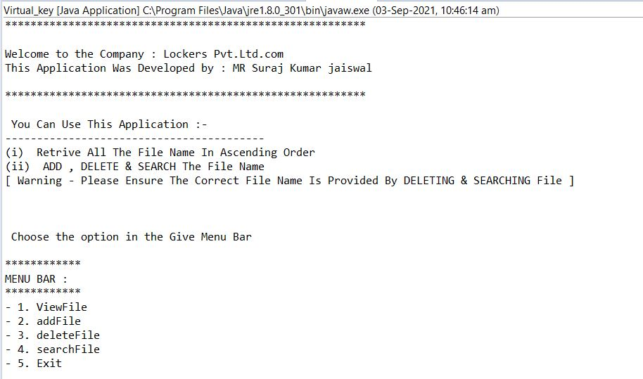

1. **Menu Bar : To choose Option –**

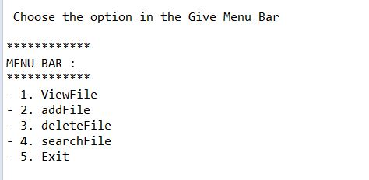

**3 – Option 1 : View File in Ascending order –**

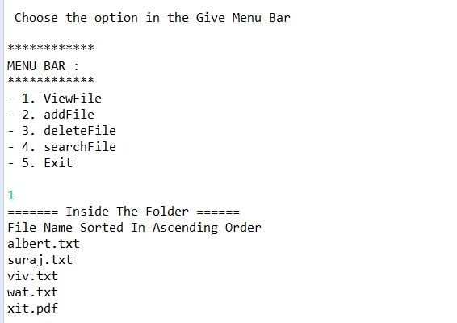

**4- Option 2 : Add File –**

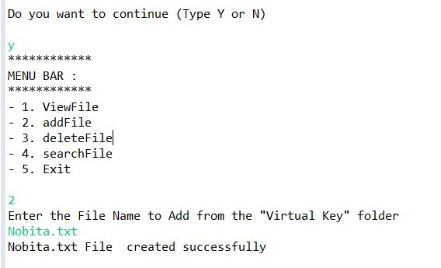

**5 – option 2 : Add File :**

**If File already present it show message –**

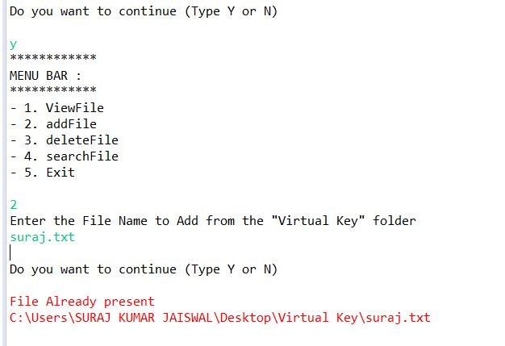

**6- option 3 : Delete File –**

**If file is deleted successfully , it show message**

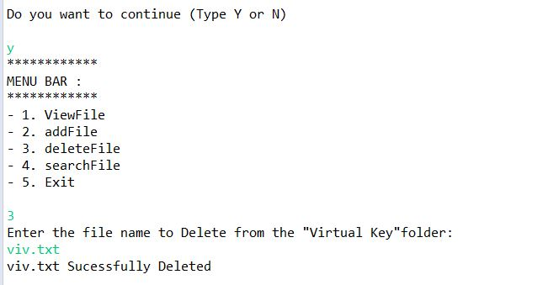

**7 – Option 3 : Delete File –**

**If file deleted unsuccessfully , it show message File Not Found**

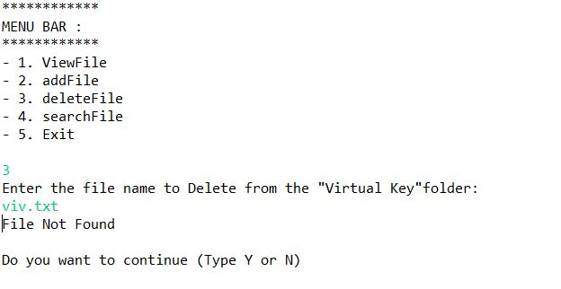

**8- Option 4: Search File –**

**If file is present in the folder , it show message like Successfully Operation**

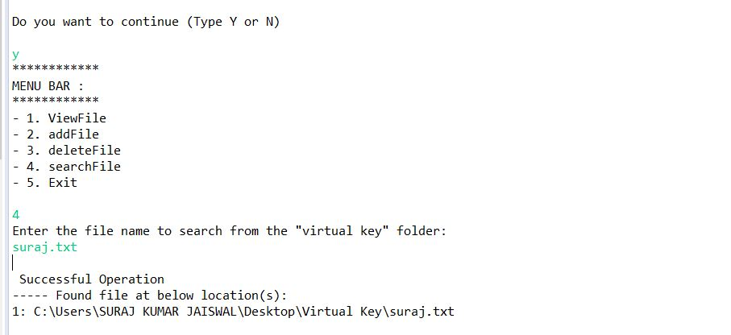

**9 – option 4 : Search File-**

**If file is not present in the folder its show message Unsuccessfully Message**

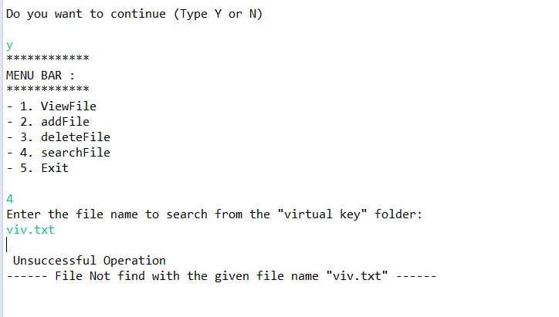

**10 – Enter the Valid No :**

**If user put out of menu bar option , it show message , Enter the valid number**

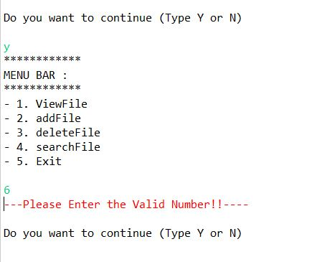

**11 – Continue Button :**

After select first option , Do you want to continue , if user put yes – y

it will continue and show the next option .

If user put No – N , it will discontinue and Exit.



**12 – Option 5 :Exit Button –**

